How to organize folders in Ne.Mo.?

Ne.Mo. user must order the folders where he saves the images. This organization is used to uniquely identify the cells.
In a folder called Images, the user creates some sub-folders, named according to the colture.
For example,
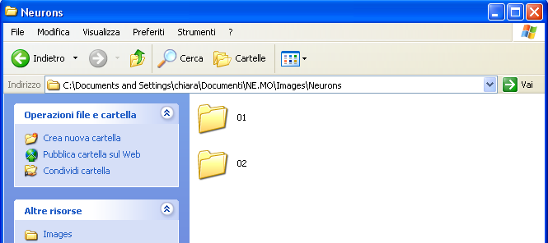

here there are only two folder, in Images\Neurons, for the first and the second colture.
In each of these, there are some sub-folders, named with the colture number and the cell number. In fact, the cells in a colture must be numbered, so we are sure that the cell is uniquely identified.
For example,
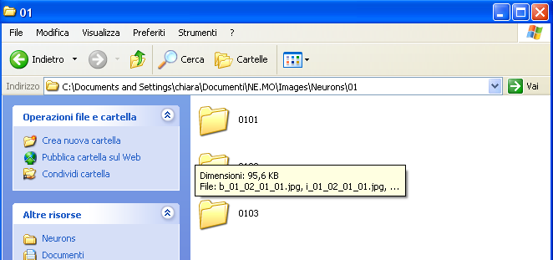

In the first colture, there are three cells.
In each folder, there is the cell image, saved in .jpg.
Finally, the image nomenclature is very important, because in it there are alla the information about the cell in a particular colture photographed in a particular day.
For example, for p_02_03_01_1.jpg:
- p is for “photo”. The other letters used are b for binary image and s for skeleton (skeleton is a binary image where the neuronal structure is reduced to one pixel-lines;
- 02 is the colture number;
- 03 is the cell number;
- 01 is the day numeration respect to first photograph done;
- 1 is the day numeration respect to the place in colture.

